COIN VALUES
KS1 – 2002 Paper
1.
2.
KS1 – 2003 Paper 1
3.
KS1 – 2004 Paper 1
4.
5.
KS1 – 2004 Paper 2
6.
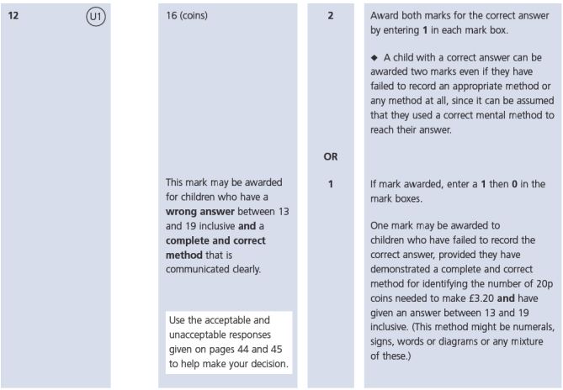
KS1 – 2005 Paper 1
7.
20

8.
10

KS1 – 2005 Paper 2
9.
1.75 pounds

KS1 – 2007 Paper 1
10.
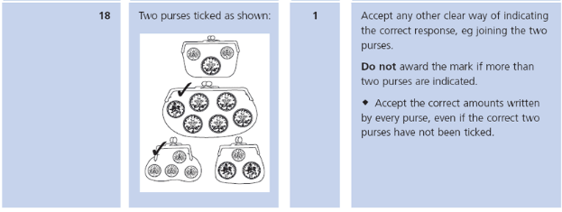
KS1 – 2007 Paper 2
11.
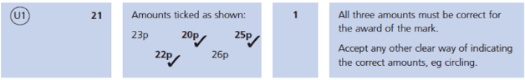
KS1 – 2009 Paper 1
12.
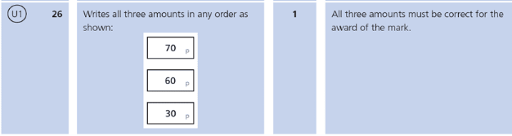
KS1 – 2009 Paper 2
13.
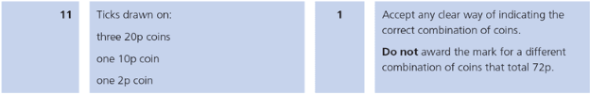
KS1 – 2016 Paper - Reasoning
14.
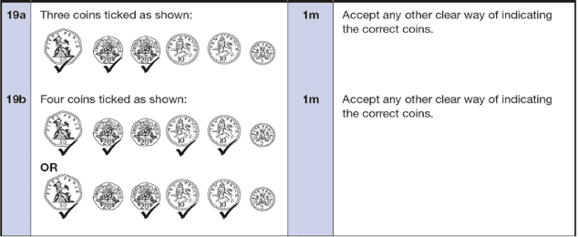
KS1 – 2016 Paper – Reasoning (Second)
15.
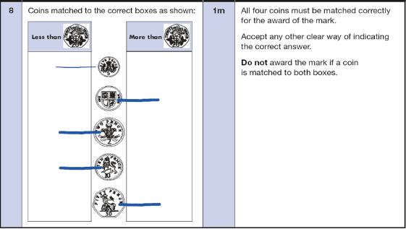
16.
KS1 – 2017 Paper – Reasoning
17.
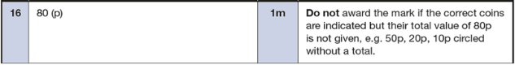
KS1 – 2018 Paper – Reasoning
18.
19.
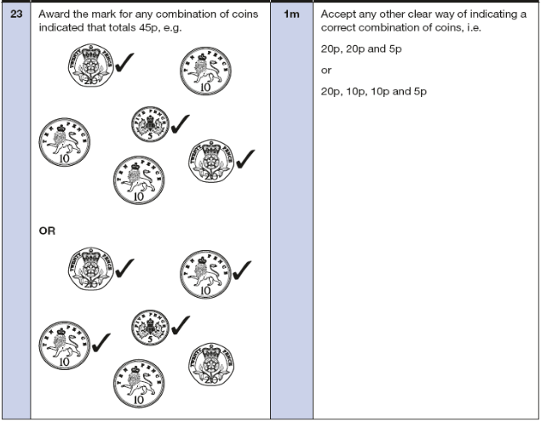
KS1 – 2019 Paper – Reasoning
20.
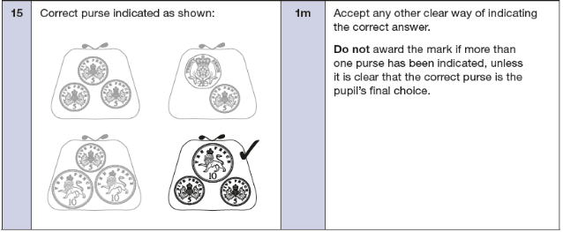

21.
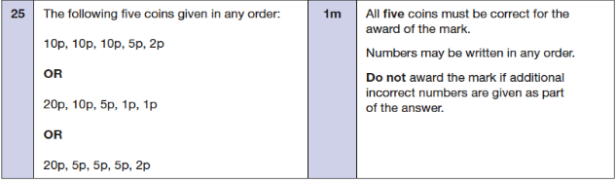
KS1 – 2022 Paper – Reasoning
22.
